Experiment 8
8.Execute and display the results for the following Nmap service version and OS detection commands in Kali Linux Operating System:
i) Detect the version of services running
ii) Aggressive scan
iii) Detect operating system of the target

Aim: To execute and study Nmap commands for service version detection, aggressive scanning, and operating system detection in Kali Linux Operating System.
i) Detect the Version of Services Running
Command:
nmap -sV 127.0.0.1
Explanation:
- nmap — A network scanning tool.
- -sV — Detects service versions running on open ports.
- 127.0.0.1 — Refers to the local computer.
Expected Output:
Starting Nmap 7.99
Nmap scan report for localhost (127.0.0.1)
Host is up.
PORT STATE SERVICE VERSION
22/tcp open ssh OpenSSH ...
Nmap done: 1 IP address scanned
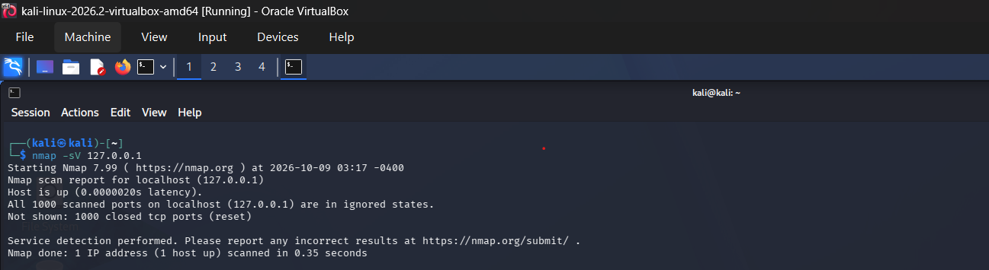
ii) Aggressive Scan
Command:
nmap -A 127.0.0.1
Explanation:
The -A option enables several advanced detection features, including:
- Operating system detection attempts
- Service version detection
- Default script scanning
- Traceroute where supported
Expected Output:
Starting Nmap 7.99
Nmap scan report for localhost (127.0.0.1)
Host is up.
PORT STATE SERVICE VERSION
...
Nmap done: 1 IP address scanned
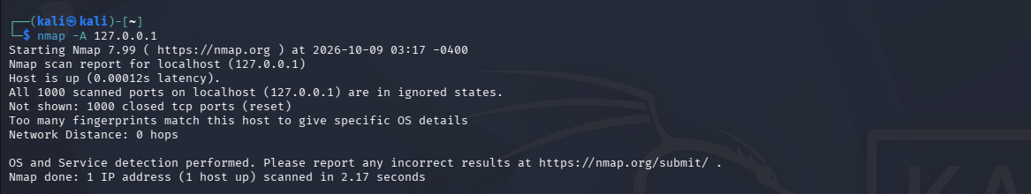
iii) Detect the Operating System of the Target
Command:
sudo nmap -O 127.0.0.1
Explanation:
- sudo — Runs the command with administrator privileges.
- nmap — Network scanning tool.
- -O — Capital letter O, used for operating system detection.
- 127.0.0.1 — Specifies the local computer.
If prompted for a password, enter your Kali Linux login password. The terminal will not show characters while you type.
Expected Output:
A possible output is:
Starting Nmap 7.99
Nmap scan report for localhost (127.0.0.1)
Host is up.
OS detection performed.
Nmap done: 1 IP address scanned
Nmap may instead display an OS guess or state that it could not identify the operating system. This depends on the network responses available.
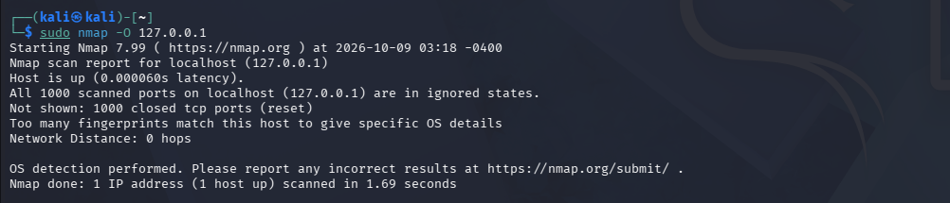
Result: Thus, the Nmap commands for service version detection, aggressive scanning, and operating system detection were studied and executed in Kali Linux, and the outputs were observed.
Final command summary
Task | Command
Service version detection | nmap -sV 127.0.0.1
Aggressive scan | nmap -A 127.0.0.1
OS detection | sudo nmap -O 127.0.0.1

